INTRODUCTION
Any physical activity in this world, whether carried out by human beings or by nature, is cause due to flow of energy in one form or the other. The word ‘energy’ itself is derived from the Greek word ‘en-ergon’, which means ‘in-work’ or ‘work content’. The work output depends on the energy input. Thus in all industrial operation, the input of energy is must to obtained the output from in the form of work. Over the years due to rapid industrialization and population growth the requirements of energy has increased manifolds. It is also known that usage of Fossils fuels as compared to other energy sources is maximum, which is unsustainable. Moreover, during their uses the environmental issues have also been encountered. Overall view of this situation has made man to look for other sustainable sources of energy like green fuels, solar energy and battery technology.
Classification
Energy sources are classified into following two category

1. Conventional or Non-Renewable Sources
Conventional energy resources which are being traditionally used for many decades and were in common use around oil crisis of 1973 are called conventional energy resources, e.g., fossil fuel, Coal

2. Non-Conventional or Renewable Sources
Non-conventional energy resources which are considered for large scale use after oil crisis of 1973, are called non-conventional energy sources, e.g., solar, wind, Hydro, Tidal

Solar Energy:
The electromagnetic radiation from sun is commonly known as solar energy. These radiations are resulted from thermo nuclear fusion reaction on the surface of sun. All the radiation from the sun is not in the same wavelength range. Almost 92% lie in the range of 315 nm to 1400nm. The estimated amount of solar flux reaching the atmosphere of earth is approximately 1400W/m²min.and that of heat equivalent is 2.68 X 10²⁴ J/Year. The eco system of earth utilizes about 0.2-0.5 % of total amount of solar energy received. It indicates clearly that large amount solar energy get wasted, which otherwise can be immense use for satisfying needs of humans.
Advantage of solar energy:
- It is non-polluting and non-depleting source of energy.
- It is renewable source of energy.
- It is available abundantly.
In spite of this advantage, the use of solar energy in large scale is still not in practice, due to following reasons,
- Non availability of intense light in all areas throughout year
- Difficulties faced in economic collection and conversion of solar energy into other forms of energy such as electricity.
The solar energy has been successfully used in following purpose
- Heating: Used for water and space heating in colder countries.
- Electricity: Using solar energy electric energy can be generated.

Flat Plate Collector:
The device works on the principle of black body in which heat absorbing capacity and tendency of a black surface is utilized to achieve benefits for human.

Diagram:
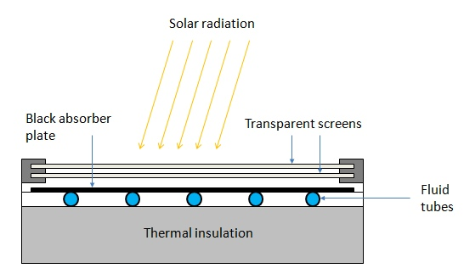
Construction:
These are the main components of a typical flat-plate solar collector:
- Black surface - absorbent of the incident solar energy
- Glazing cover - a transparent layer that transmits radiation to the absorber, but prevents radiative and convective heat loss from the surface
- Tubes containing heating fluid to transfer the heat from the collector
- Support structure to protect the components and hold them in place
- Insulation covering sides and bottom of the collector to reduce heat losses

Application
Some advantages of the flat-plate collectors are that they are: Easy to manufacture
- Low cost, Collect both beam and diffuse radiation
- Permanently fixed (no sophisticated positioning or tracking equipment is required)
- Little maintenance

PHOTO VOTAIC CELL (SOLAR CELL)
A conventional solar cell structure is shown in figure:
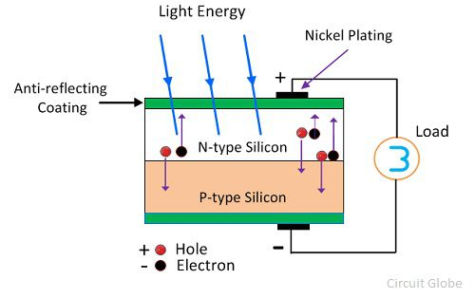
Semiconductors like silicon has the capacity to absorb light and deliver a portion of the energy of the absorbed photons to carry charge carriers (electrons and hole).Thus solar cell is a semiconductor diode that has been designed carefully so that it can absorb the light energy efficiently and convert light energy from the sun into electrical energy.

Construction: A typical silicon photo voltaic cell composed of thin layer of phosphorus doped silicon (n-type) on top of boron doped (p-type) silicon. Hence these two layers form p-n junction. A metallic grid is the electrical contact of the diode and allows light to fall on the semiconductor between the grid lines. An anti-reflective layer between the grid lines increases the amount of light transmitted to semiconductor.

Working: of tiny energy packets called photon. When light radiation falls on the p-n junction diode, photon is absorbed and electron-hole pairs are generated. The electrons are diffused and collected at the n-type end and holes are diffused and collected at the p-type end. When these two ends are electrically connected through a conductor, there is a flow of current between the two ends through the external circuit. Thus photoelectric current is produced and available for use. The current output of a cell depends on its efficiency and size and is proportional to the intensity of sun light striking the surface of the cell. Therefore, photovoltaic cells are connected electrically in series or parallel circuits to produce higher voltages, currents and power levels. A number of solar cells electrically connected to each other and mounted in a support structure or frame is called a photovoltaic module. A photovoltaic array is the complete power generating unit, consisting of any number of photovoltaic modules and panels.
Advantage | Disadvantage
- Fuel source is vast and essentially infinite. | Sun light is diffuse or relatively low density energy.
- Does not contribute to global change or pollution. | - Poor reliability of auxiliary elements including storage.
- No moving parts and so no wear and tear and low operating cost | 3. Sun light is a diffuse, i.e., it is relatively low density energy.
High reliability in modules. | Energy can be produced only during the day time.

Battery Technology:
Battery is a combination of two or more electrochemical cells. These electrochemical cells store energy in the form of chemical energy, and this is converted into electrical energy when connected to an electrical circuit in which an electrical current can flow. A cell consists of two electrodes with an electrolyte placed between them. The negative electrode is known as the cathode, while the positive electrode is known as the anode. The electrolyte between them can either be a liquid or a solid. Today many cells are enclosed in a special container, and there is an element known as a separator placed between the anode and cathode. This is porous to the electrolyte and prevents the tow electrodes from coming into contact with each other.
Batteries are becoming more widely used. As the use of portable and mobile equipment increases, so does the use of battery technology. The increasing demands being placed on batteries has meant that the technology has developed considerably in the past few years, and more development can be expected in the future. With the huge demand for batteries, there is a wide variety of different battery and cell technologies available. These range from the established non-rechargeable technologies such as zinc-carbon and alkaline batteries to rechargeable batteries that have moved from NiCd through NiMH cells to the newer lithium ion rechargeable batteries. Another area of battery technology that is becoming more important is the green or environmental aspects. Some of the old battery technologies contain chemicals which can be considered as toxic. Now new designs are seeking to use more environmentally friendly chemicals. Nickel cadmium cells are now considered as being environmentally unfriendly and are not as widely used as they were previously. Other batteries also contain harmful chemicals and this is likely to have a significant impact on the direction of future developments.

Primary and secondary cells
Although there are many different types of battery, there are two main categories of cell or battery that can be used to provide electrical power. Each type has its own advantages and disadvantages and therefore each type of battery is used in different applications, although they can often be interchanged:
- Primary batteries: Primary batteries are essentially batteries that cannot be recharged. They irreversibly transform chemical energy to electrical energy. When the chemicals within the battery have all reacted to produce electrical energy and they are exhausted, the battery or cell cannot be readily restored by electrical means.
- Secondary batteries: Secondary batteries or secondary cells are different to primary ones in that they can be recharged. The chemical reactions within the cell or battery can be reversed by supplying electrical energy to the cell, restoring their original composition.

BATTERY TYPES & THEIR PROEPRTIES
CELL TYPE | NOMINAL VOLTAGE  V | CHARACTERISTICS
Primary cells and batteries
Alkaline manganese dioxide | 1.5 | Widely available, providing high capacity. Shelf life normally up to about five years. Capable of providing moderate current.
Lithium thionyl chloride | 3.6 | Good for low to medium currents. High energy density and long shelf life.
Lithium manganese dioxide | 3.0 | Long shelf life combined with high energy density and moderate current capability.
Mercury oxide | 1.35 | Used for button cells but are virtually phased out now because of the mercury they contain.
Silver oxide | 1.5 | Good energy density. Mainly used for button cells.
Zinc carbon | 1.5 | Widely used for consumer applications. Low cost, moderate capacity. Operate best under intermittent use conditions.
Zinc air | 1.4 | Mostly used for button cells. Have a limited life once opened and low current capability but a high energy density.
Secondary cells and batteries
Nickel cadmium  NiCd | 1.2 | Were in very common use, but now giving way to NiMH cells and batteries in view of environmental impacts. Low internal resistance and can supply large currents. Long life if used with care.
Nickel metal hydride  NiMH | 1.2 | Higher capacity but more expensive than NiCads. Charging must be carefully controlled. Being used in many applications where NiCads were previously used.
Lithium ion  Lion |  | Highest capacity and they are now widely used in many laptops, mobile phones, cameras. . etc. Charging must be carefully controlled and often have a limited life ~ typically 300 charge discharge cycles.
Lead acid | 2.0 | Widely used for automotive applications. Relatively cheap, but life expectancy often short.

Battery definitions, terms, & terminology
- Anode: The definition for the anode is the electrode at which an oxidation reaction occurs. This means that the anode electrode is a supplier of electrons. However the electron flow reverses between charge and discharge activities. As a result, the positive electrode is the anode during charging and the negative electrode is the anode during discharging.
In order to prevent confusion, the anode is normally defined for its activity during the discharge cycle. In this way the term anode is used for the negative electrode in a cell or battery.
- Battery: A battery is the generic name for a unit that creates electrical energy from stored chemical energy. Strictly it consists of two or more cells connected in an appropriate series / parallel arrangement to provide the required operating voltage and capacity to meet its operating requirements. The term battery is also frequently used to refer to a unit consisting of a single cell, especially when it contains battery management circuitry.
- Cathode: The definition of a cathode is the electrode in a battery or other system at which a reduction reaction occurs. The electrode takes up electrons from an external circuit. Accordingly, the, the negative electrode of the battery or cell is the cathode during charging and the positive electrode is the cathode during discharging.
To prevent confusion the cathode is normally specified for the discharge cycle. As a result, the name cathode is commonly used for the positive electrode of the cell or battery.
- Capacity: The capacity of a battery or cell is defined as the amount of energy that it can deliver in a single discharge. Battery capacity is normally specified in amp-hours (or milli-amp-hours) or as watt-hours.
- Charge rate or C-rate: The definition of the charge rate or C-rate of a battery or cell is the charge or discharge current in Amperes as a proportion of the rated capacity in Ah. For example, in the case of a 500 mAh battery, a C/2 rate is 250 mA and a 2C rate would be1 A.
- Constant-Current Charge: This refers to a charging process where the level of current is maintained at a constant level regardless of the voltage of the battery or cell.
- Constant-Voltage Charge: - This definition refers to a charging process in which the voltage applied to a battery is held at a constant value over the charge cycle regardless of the current drawn.
- Cycle Life: The capacity of a rechargeable cell or battery changes over its life. The definition of the battery life or cycle life of a battery is number of cycles that a cell or battery can be charged and discharged under specific conditions, before the available capacity falls to a specific performance criteria - normally 80% of the rated capacity.
- Cut-off voltage: As a battery or cell is discharged it has a voltage curve that it follows - the voltage generally falling over the discharge cycle. The definition for a cell or battery of the cut-off voltage cell or battery is the voltage at which the discharge is terminated by any battery management system. This point may also be referred to as the End-of-Discharge voltage.
- Deep Cycle: A charge discharge cycle in which the discharge is continued until the battery is fully discharged. This is normally taken to be the point at which it reaches its cut-off voltage, typically 80% of discharge.
- Energy Density: The volumetric energy storage density of a battery, expressed in Watt-hours per litre (Wh/l).
- Power Density: The volumetric power density of a battery, expressed in Watts per litre (W/l).
- Rated Capacity: The capacity of a battery is expressed in Ampere-hours, Ah and it is the total charge that can be obtained from a fully charged battery under specified discharge conditions
- Self-Discharge: It is found that batteries and cells will lose their charge over a period of time, and need re-charging. This self-discharge is normal, but various according to a number of variables including the technology used and the conditions. Self-discharge is defined as the recoverable loss of capacity of a cell or battery. The figure is normally expressed in a percentage of the rated capacity lost per month and at a given temperature. The self-discharge rate of a battery or cell is very dependent upon the temperature.
- Separator: This battery terminology is used to define the membrane that is required within a cell to prevent the anode and cathode shorting together. With cells being made more compact, the space between the anode and cathode becomes much smaller and as a result the two electrodes could short together causing a catastrophic and possibly explosive reaction. The separator is an ion-permeable, electronically non-conductive material or spacer that is placed between the anode and cathode.

Lead acid battery
- Positive plate: This is covered with a paste of lead dioxide.
- Negative plate: This is made of sponge lead.
- Separator: This is an insulating material between the two plates, but it allows the electrolyte and the ions into it to enable conduction without the two plates touching.
- Electrolyte: This consists of water and sulphuric acid
These constituents are all contained within a plastic container which acts to keep the electrolyte in and the battery together.
The overall battery will normally consist of several cells placed in series to give the required voltage as each cell is capable of providing an EMF of 2.1 volts.
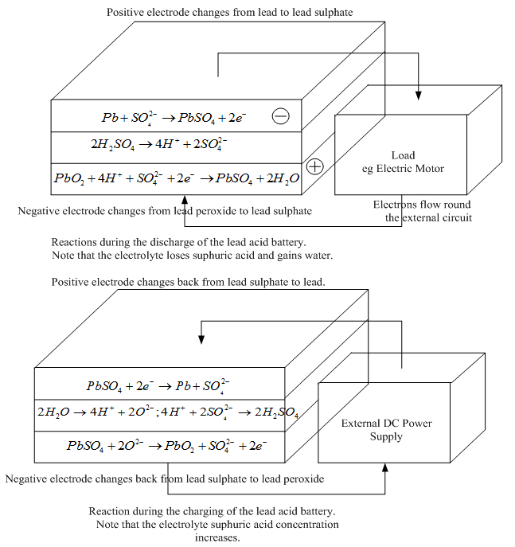

In order to enable the basic lead acid cell to produce a voltage, it must first receive charge. The voltage applied to provide this must be greater than the 2.1 volts to enable current to flow into the cell. If it were less than this, charge would actually flow out of it.
Once charged, the cell or battery will be able to provide charge to external circuits, often operating over several hours dependent upon the drain on the cell or battery.

Lead Acid Battery Advantages
- Mature technology
- Relatively cheap to manufacture and buy (they provide the lowest cost per unit capacity for rechargeable cells)
- Large current capability
- Can be made for a variety of applications
- Tolerant to abuse
- Tolerant of overcharging
- Wide range of sizes and specifications available
- Many producers worldwide

Lead Acid Battery Disadvantages
- Fails after a few years use lifespan typically 300 - 500 cycles
- Cannot always be used in a variety of orientations
- Corrosive electrolyte (can cause burns to people and corrosion on metalwork)
- Lead is not environmentally friendly
- Acid needs disposing of with care
- Not suitable for fast charging
- Must be stored in charged state once electrolyte introduced
- Typical charging efficiency only around 70%

Lithium Ion Battery
Since the late 1980s rechargeable lithium cells have come onto the market. They offer greatly increased energy density in comparison with other rechargeable batteries, though at greatly increased cost. It is a well-established feature of the most expensive laptop computers and mobile phones that lithium rechargeable batteries are specified, rather than the lower cost NiCad or NiHM cells that we have been considering earlier. The battery consists of an anode of Lithium, dissolved as ions, into a carbon. The cathode material is made up from Lithium liberating compounds, typically the three electro-active oxide materials,
- Lithium Cobalt-oxide (LiCoO₂ )
- Lithium Manganese-oxide (LiMn₂O₄
- Lithium Nickel-oxide (LiNiO₂)

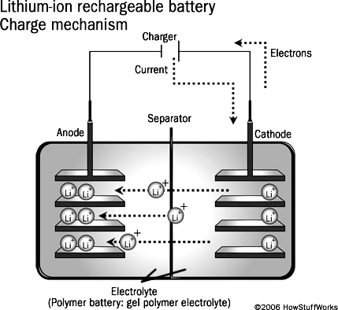

Construction:
- A positive electrode made with Lithium Cobalt Oxide has a current collector made of thin aluminum foil – cathode.
- A negative electrode made with specialty carbon has a current collector of thin copper foil – anode.
- A separator is a fine porous polymer film.
- An electrolyte made with lithium salt in an organic solvent.
- The electrolytes are selected in such a way that there should be an effective transport of Li-ion to the cathode during discharge.
- The type of conductivity of electrolyte is ionic in nature rather than electronic

Working:
- The traditional batteries are based on galvanic action but Lithium ion secondary battery depends on an "intercalation" mechanism.
Intercalation: The process where the lithium ions in the lithium ion battery are inserted into the electrode is called intercalation.
- This involves the insertion of lithium ions into the crystalline lattice of the host electrode without changing its crystal structure.
- These electrodes have two key properties. One is the open crystal structure, which allow the insertion or extraction of lithium ions and the second is the ability to accept compensating electrons at the same time. Such electrodes are called intercalation hosts.
- The chemical reaction that takes place inside the battery is as follows, during charge and discharge operation:
- The lithium ion is inserted and exerted into the lattice structure of anode and cathode during charging and discharging
- During discharge current flows through external circuit and light glows
- During charging, no the electrons flows in the opposite direction.
- During charging, lithium in positive electrode material is ionized and moves from layer to layer and inserted into the negative electrode.
During discharge Li ions are dissociated from the anode and migrate across the electrolyte and are inserted into the crystal structure of the host compound of cathode
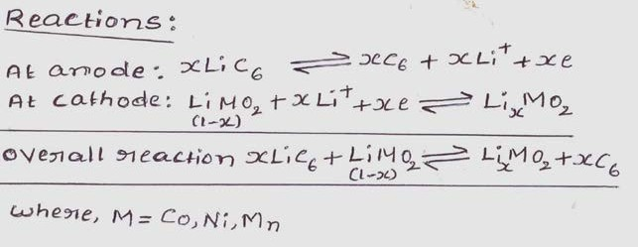

Advantages
- They have high energy density than other rechargeable batteries
- They are less weight
- They produce high voltage out about 4 V as compared with other batteries.
- No liquid electrolyte means they are immune from leaking.
- Fast charge and discharge rate
- Long cycle life, tolerate microcycles.
- Very low self-discharge rate

Disadvantage:
- They are expensive.
- Internal impedance is higher than equivalent
- Degrades at higher temperature
- It does sustain overcharging
- Long term implication is not yet clear
- They are not available in standard cell types.
- It requires to charge regularly

Applications
- The Li-ion batteries are used in cameras, calculators.
- They are used in cardiac pacemakers and other implantable device.
- They are used in telecommunication equipment, instruments, portable radios and TVs, pagers.
- They are used to operate laptop computers and mobile phones and aerospace application.
- Lithium ion rechargeable battery used as main power supply for mobile phone , PCs, digital camera replacing Nickel metal hydride cell
- Upto 1000MAh capacity and more available for use in traction application as well as stand by power.

